**28. DATABASE**

1. **MYSQL**

* MYSQL is a Relational database management system.
* A database is a collection of organized and related data that stored in a format that can easily be accessed.
* Database stores information in an organized manner in the form of tables.
* A DataBase Management System can be used to handle the data in database.
* A database stores data I structured format. A DBMS is responsible to store, access, and delete data from a database.
* MYSQL is a software program that stores and manages database.
* It is responsible for managing various database operation such as Adding, Accessing, processing of data.
* It is a fast, scalable , reliable and easy to use and this software is open-source.
* A client can not store the data directly in the database, there is need of medium software called DBMS.
* MYSQL is one of this DBMS.
* MYSQL server works in client/server or embedded system.

1. **Workbench Overview**

* MYSQL workbench provides a graphical tool for working with MYSQL servers and databases.
* We can use this for server administration, for creating Entity Relationship Diagrams
* MYSQL Workbench provides three main areas of functionality:

1. **SQL Development**:

* Enables you to create and manage connections to database servers.
* MYSQL Workbench provides the capability to execute SQL queries on the database connections using the built-in SQL Editor.

1. **Data Modeling**:

* Enables to create models of database schema graphically.
* Reverse and forward engineer between a schema and a live database, and edit all aspects of your database using the comprehensive Table Editor.
* The Table Editor provides easy-to-use facilities for editing Tables, Columns, Indexes, Triggers, Partitioning, Options, Inserts and Privileges, Routines and Views.

1. **Server Administration**:

* Enables to create and administer server instances.

1. **CRUD Operations**

**Create**

CREATE DATABASE databasename;

CREATE TABLE table_name ( column1 datatype, …..);

**Read**

SELECT * FROM table_name;

SELECT column1, column2 FROM table_name;

**Update**

UPDATE table_name SET column1 = value1, column2 = value2,…. WHERE condition;

**Delete**

DELETE FROM table_name WHERE condition;

**Insert**

INSERT INTO table-name (column 1, column 2, column 3,….) VALUES (value 1, value 2, value 3…..);

**Example**

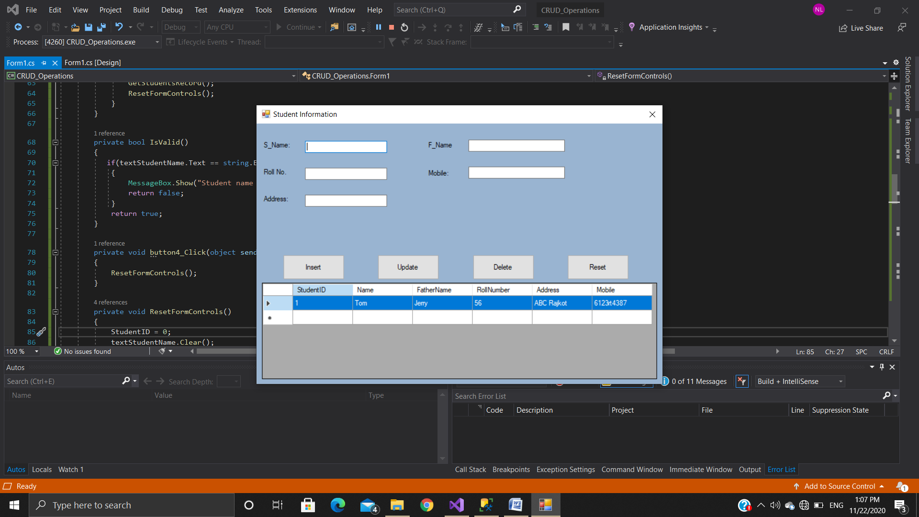

**INSERT DATA**

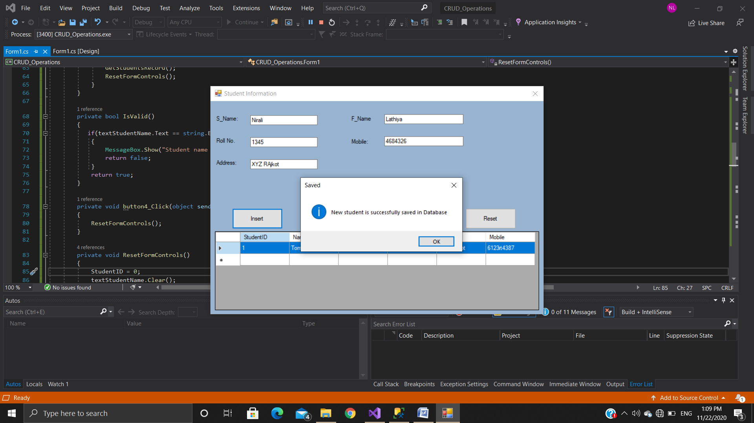

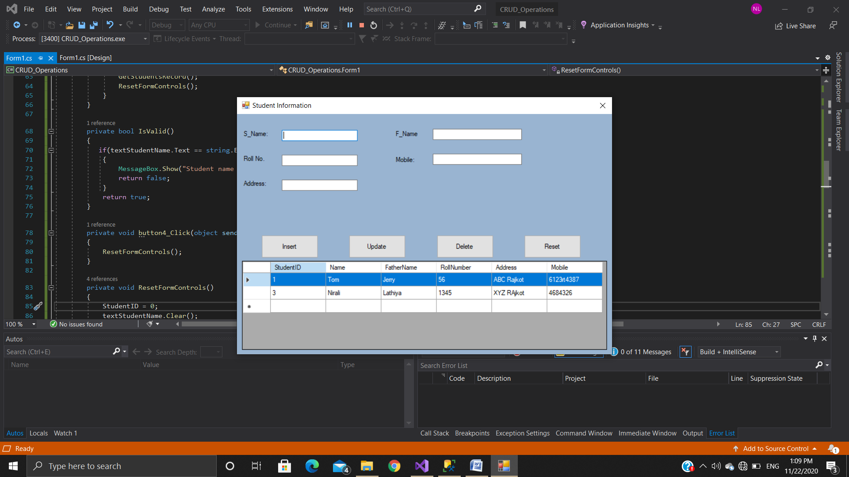

**Update Data**

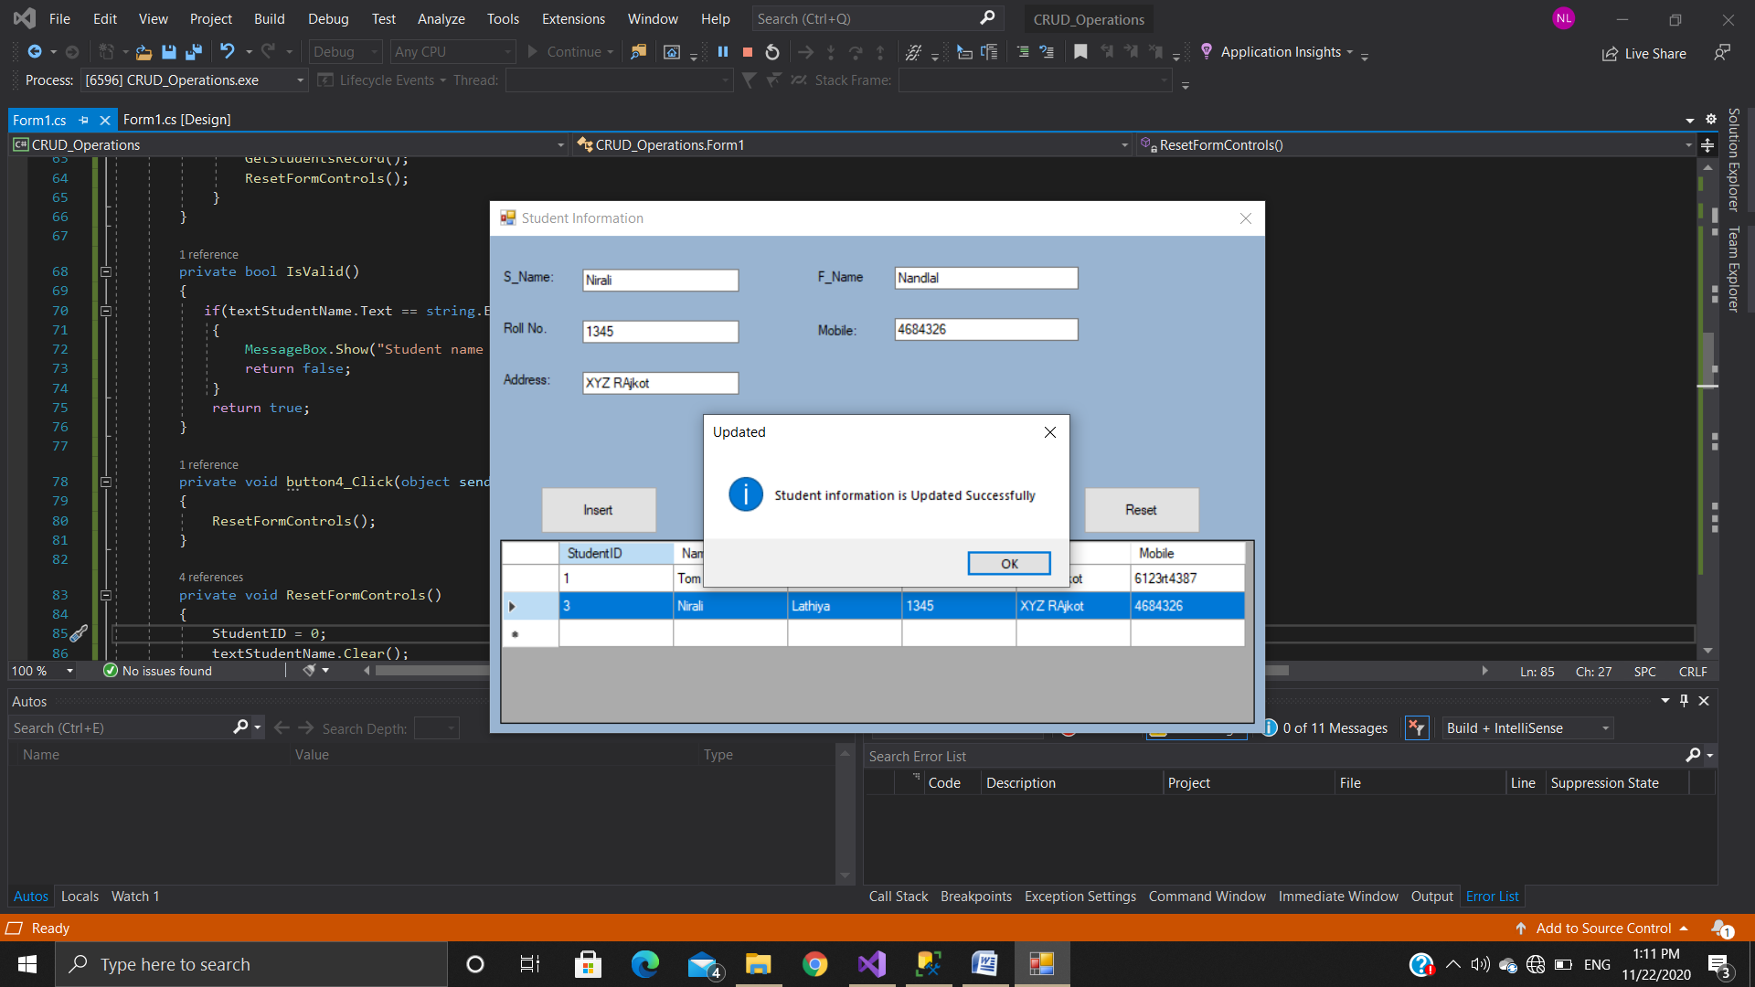

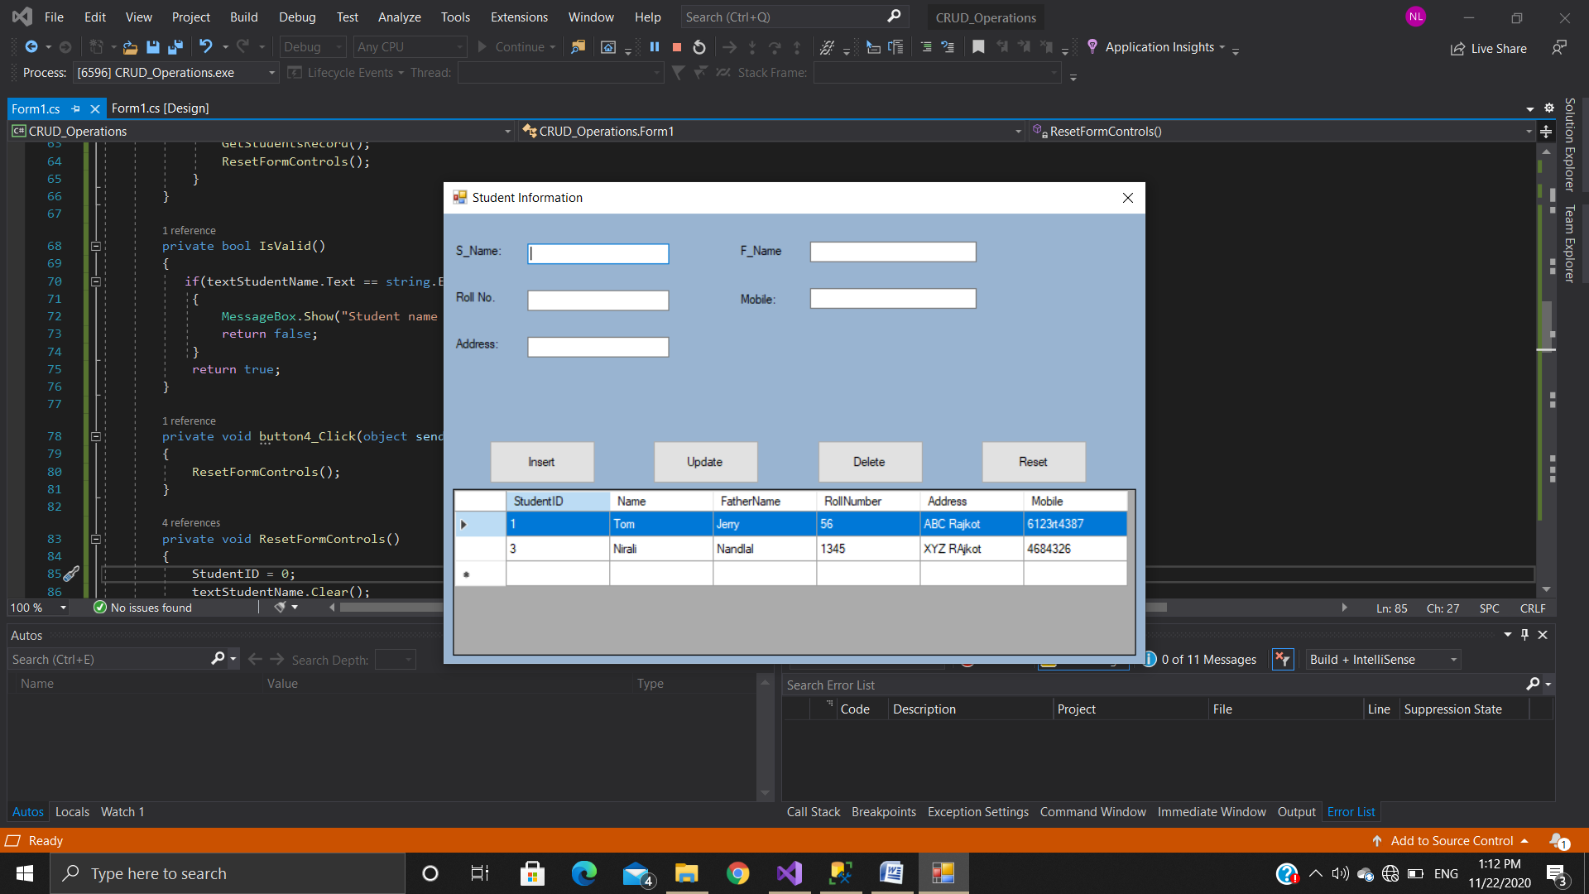

**Delete Data**

